1. 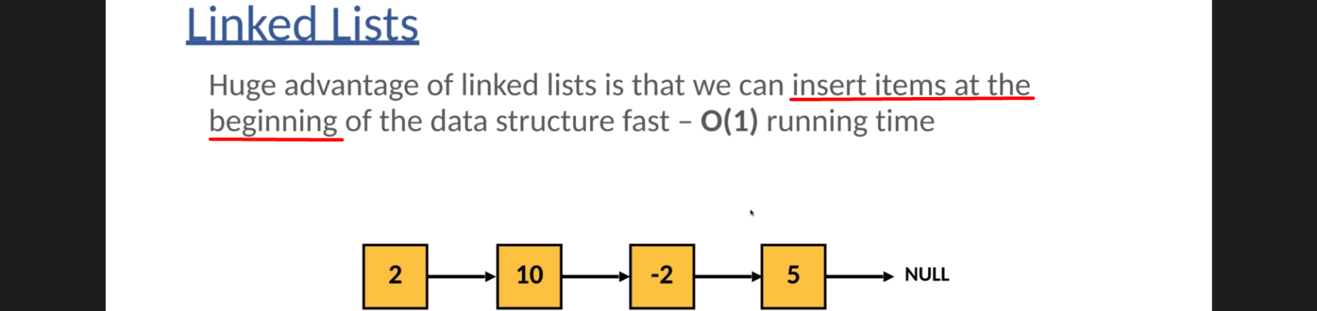
2. 
3. 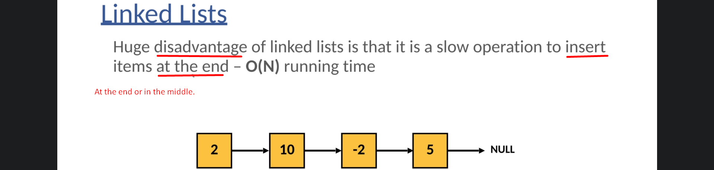
4. 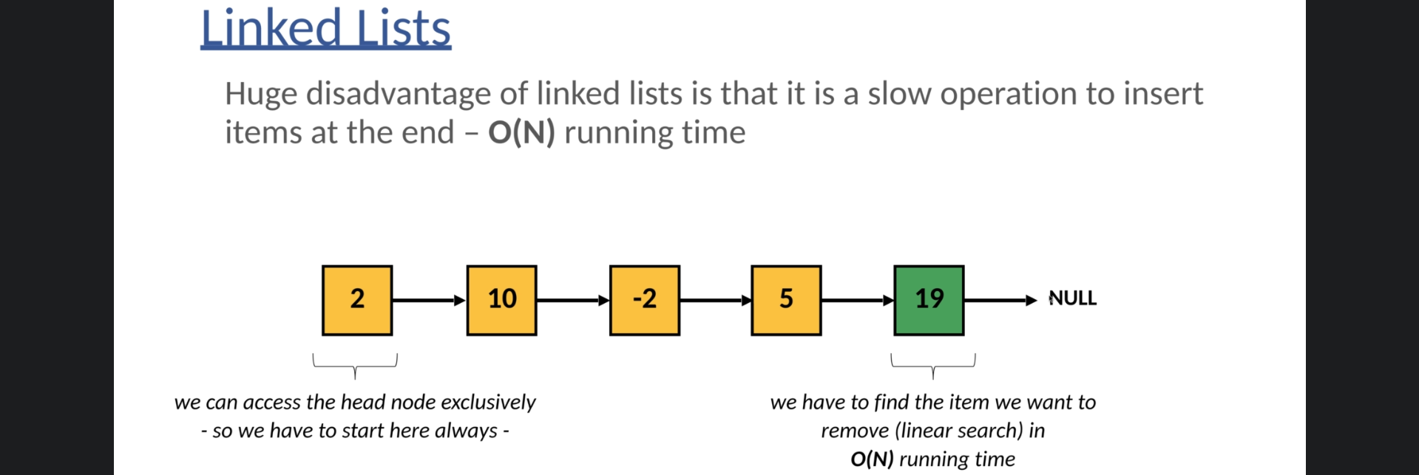
5. 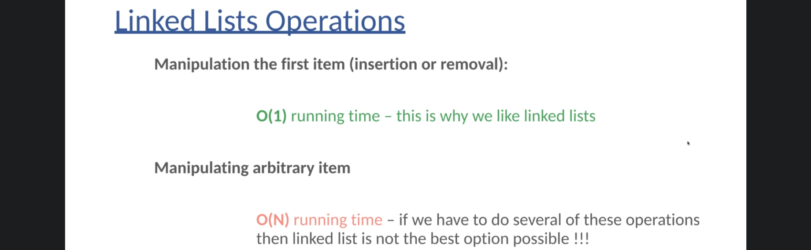
6. 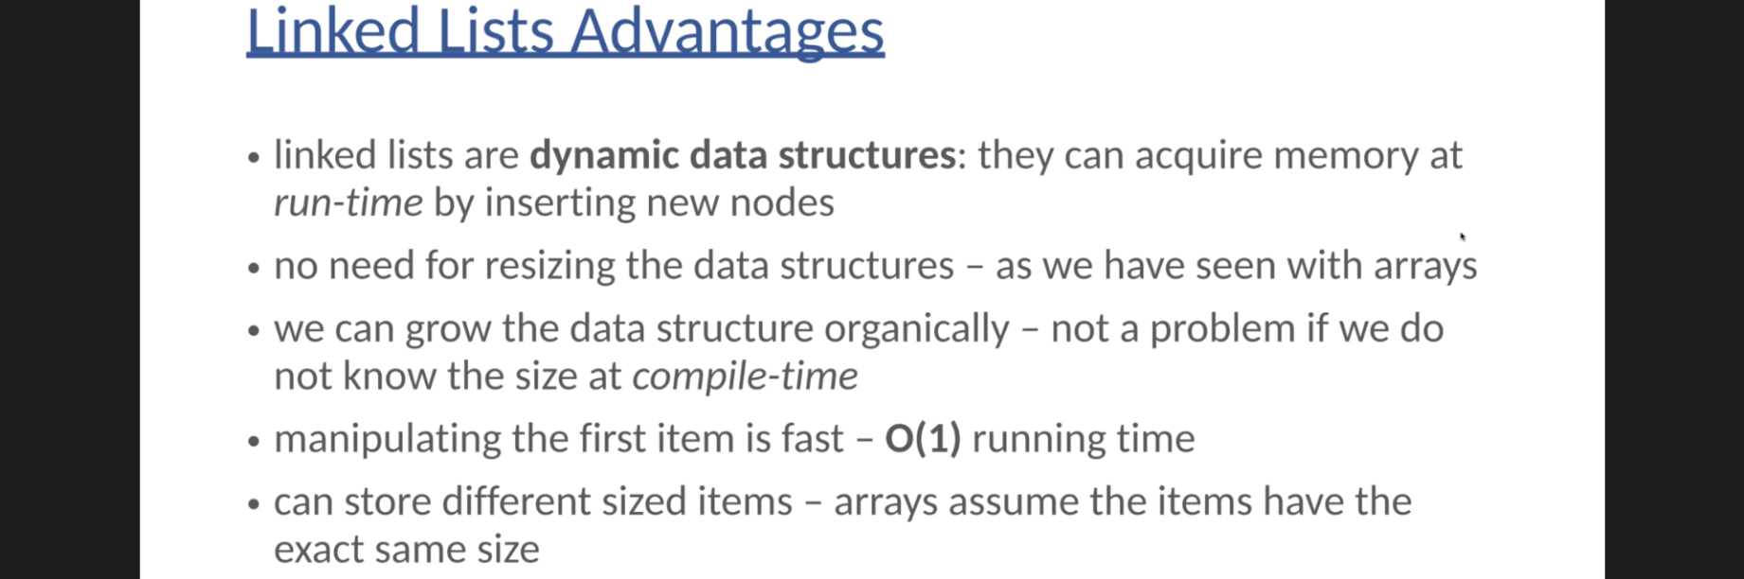
7. 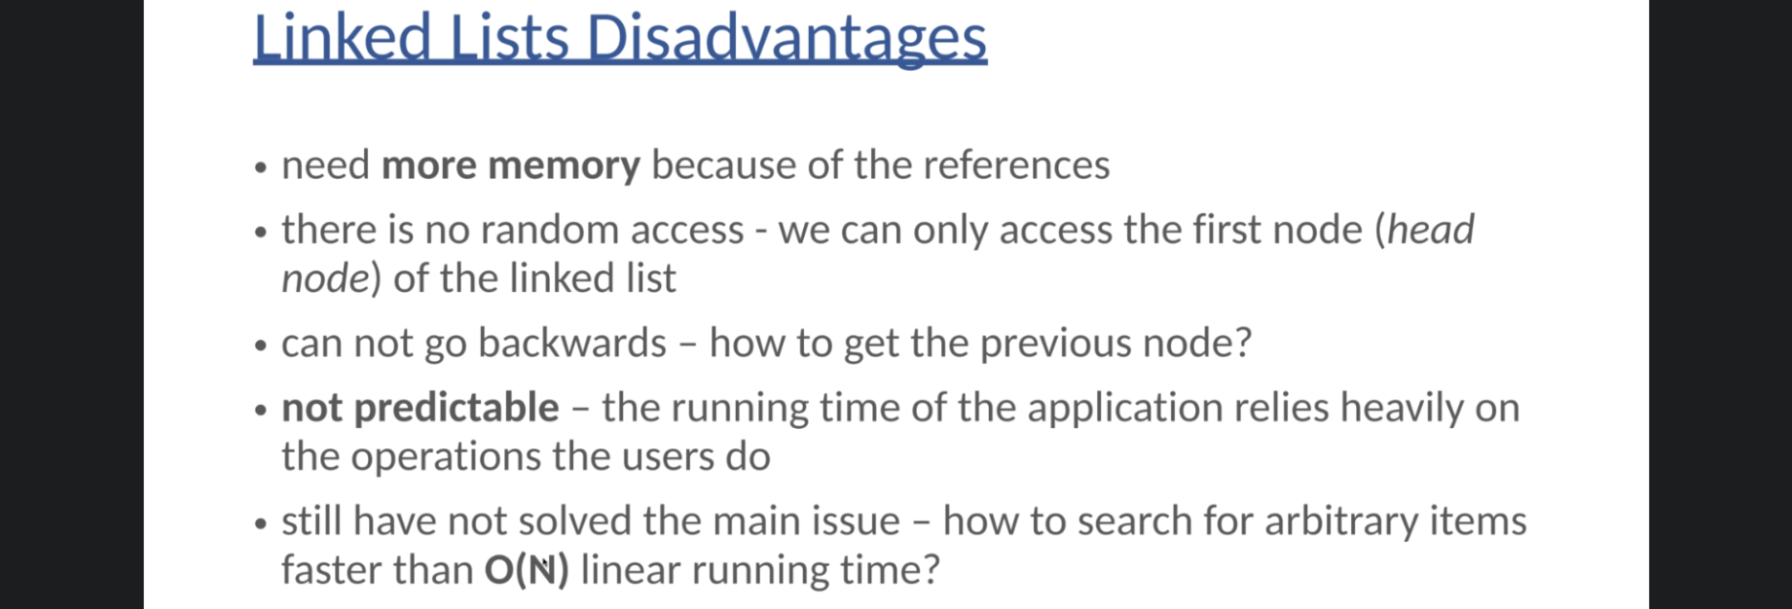
8. **Predictable**: In case of Array and Linked List, the running time of an app is not predictable as it depends on the operations a user is going to perform on them.  
   Array is good if insertion and deletions are done at the end whereas  
   Linked List is good if they are performed at the beginning.  
   But we are not sure a user is going to perform operations on which end.   
   **Solution**: Binary Search Tree. Logarithmic running time complexity.